
Saad Mughal
F2023-009
Total Marks: 10
Due 16 February 2026

Computer Networks LAB

Week 2

Basic Linux Commands

Course Lecturer: Shaiza Rizwan
Lab Instructor: Hasnain Ahmad
Section: C

Computer Networks LAB (LAB-209) - Lab 01
Overview of Basic Linux Commands, Process Management, and Network Management

Task 1
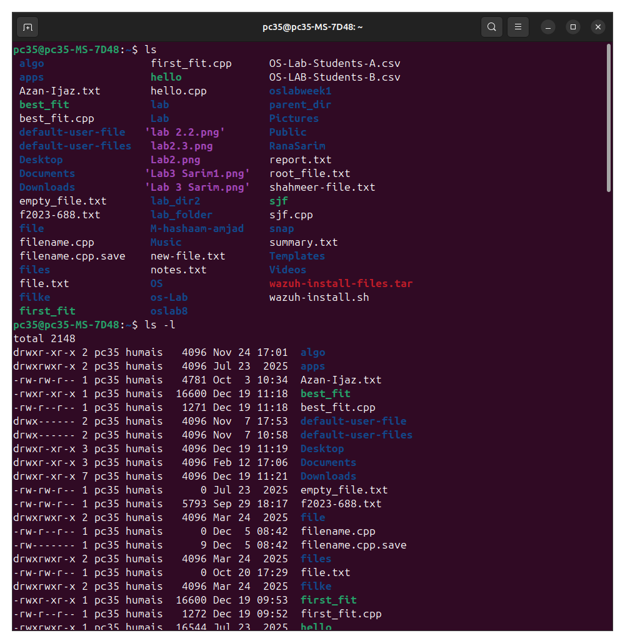
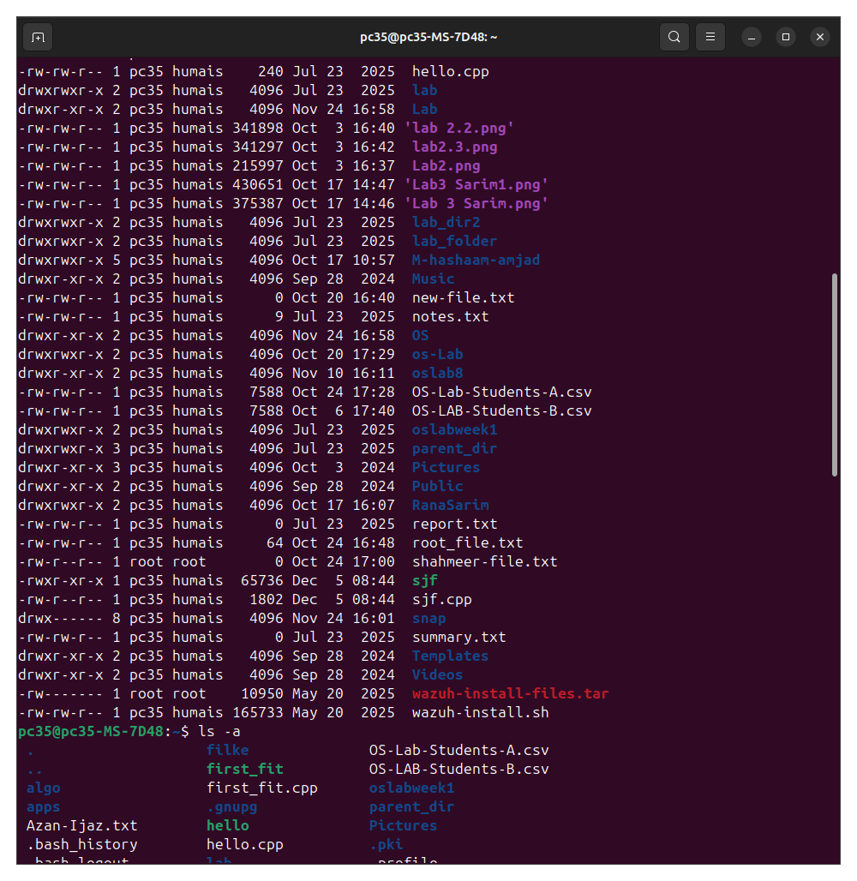
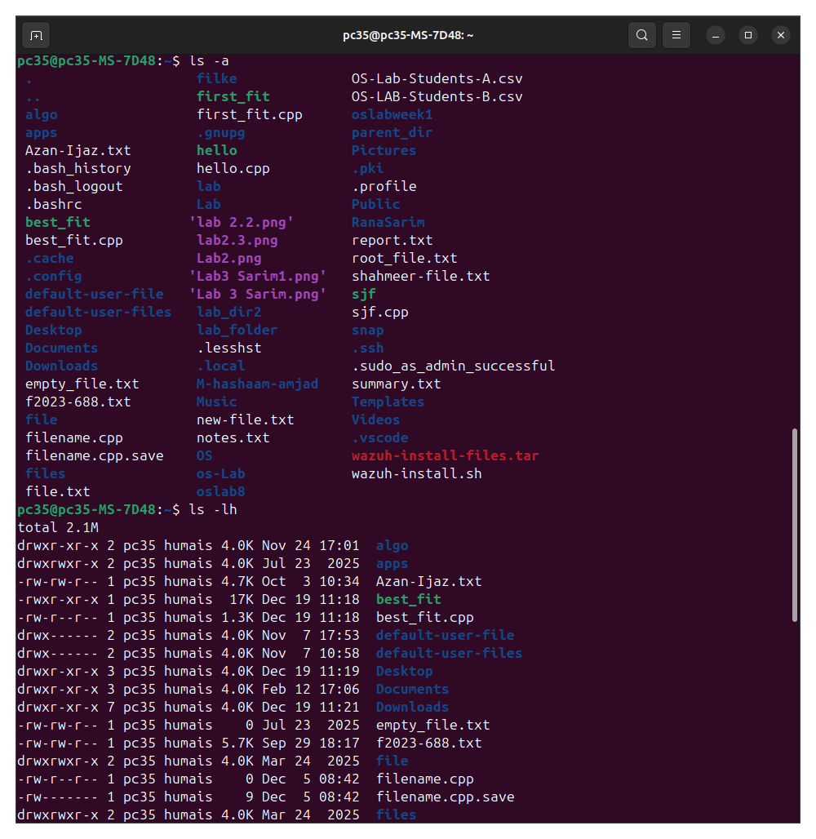
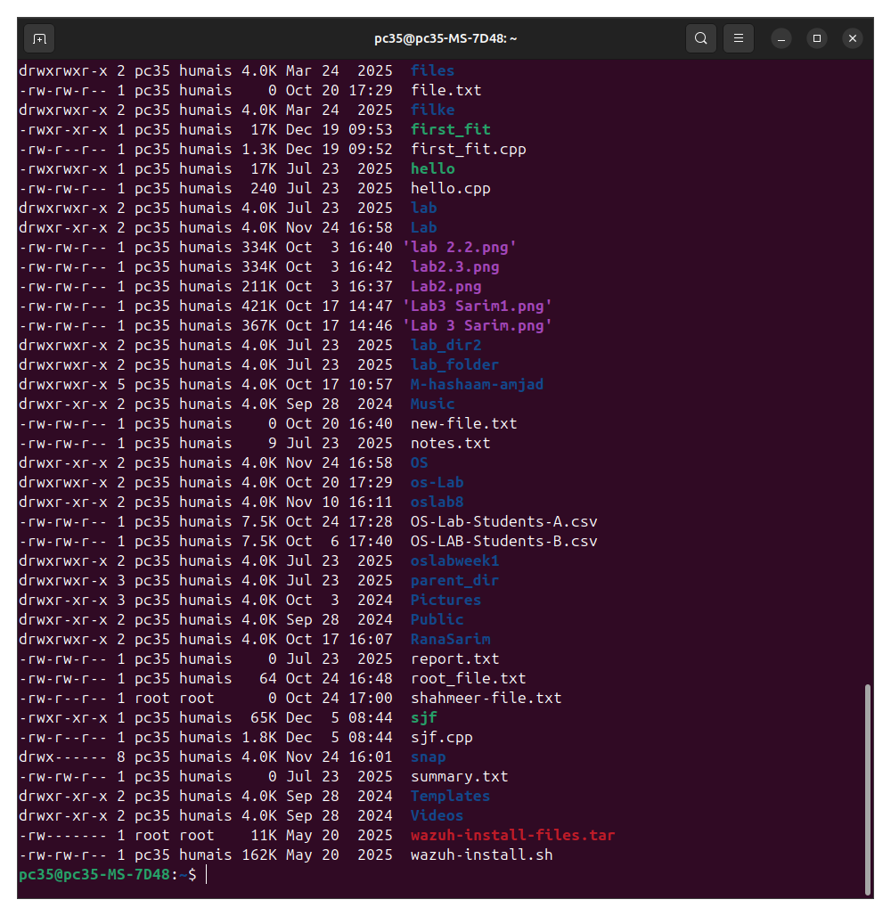
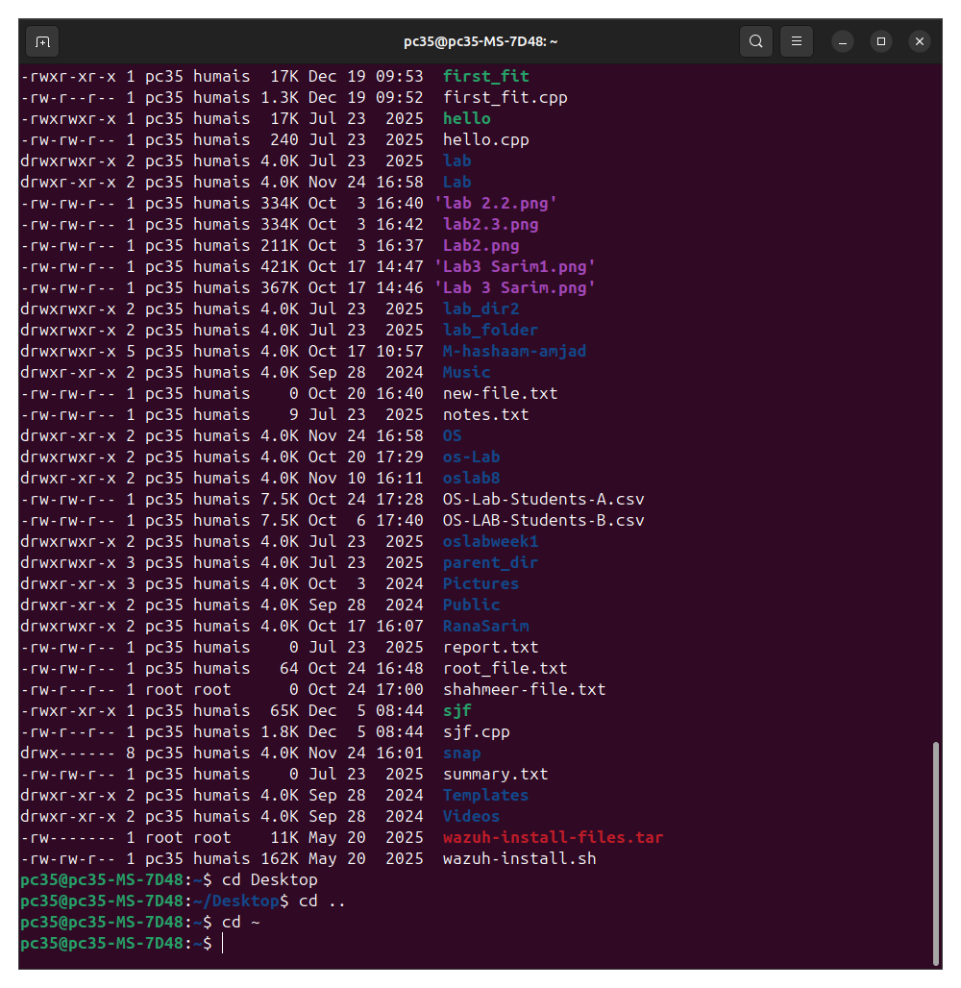
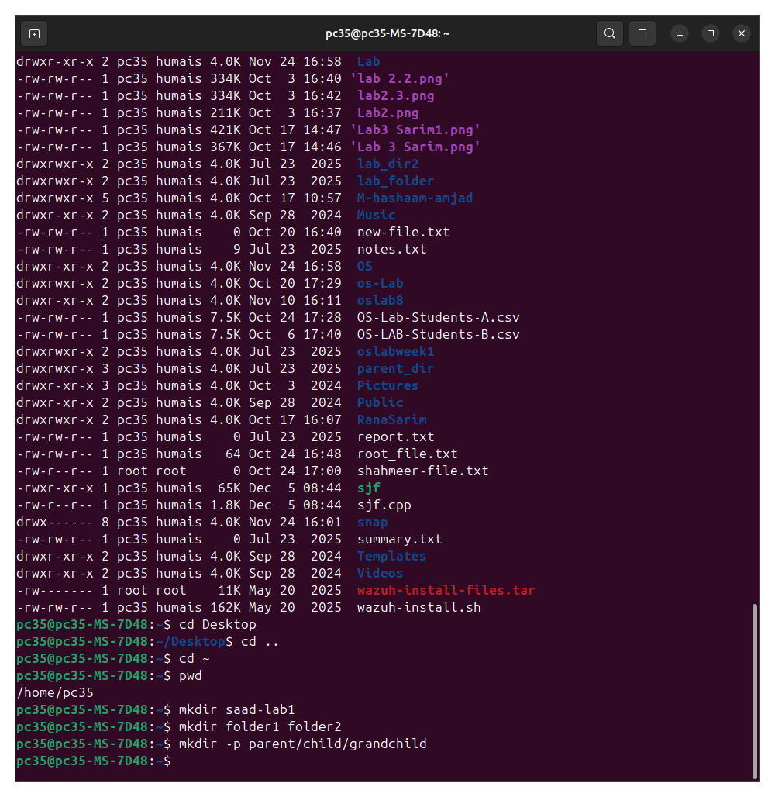
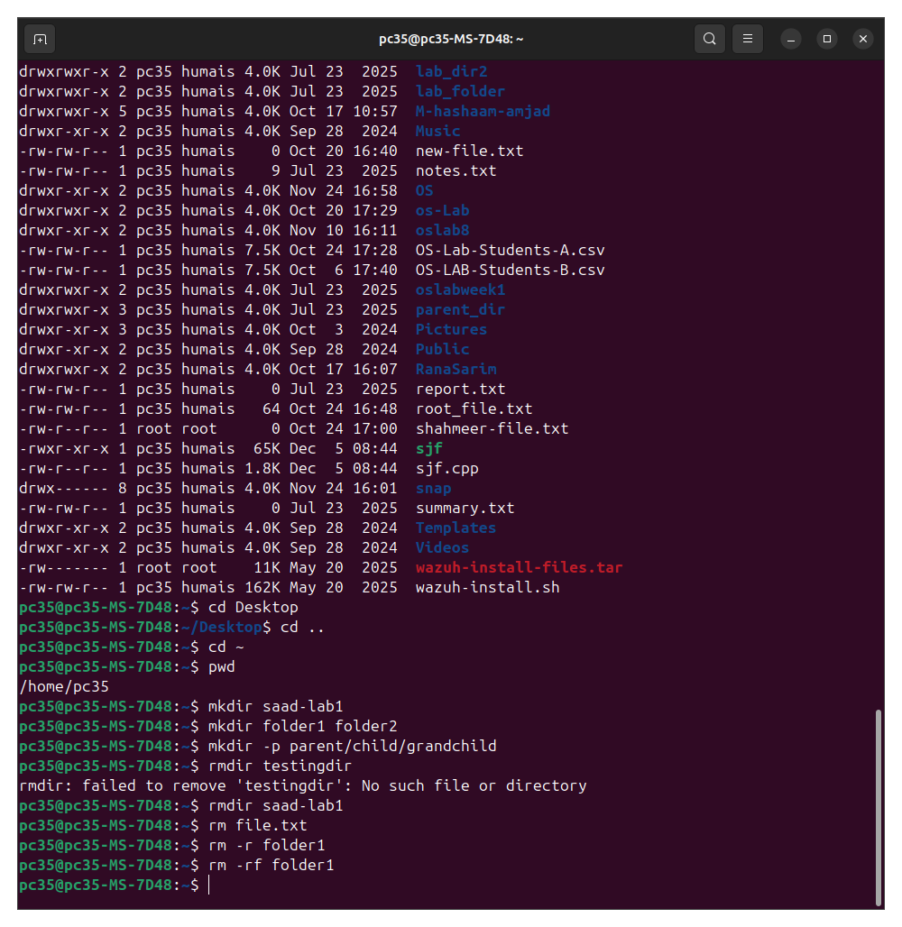
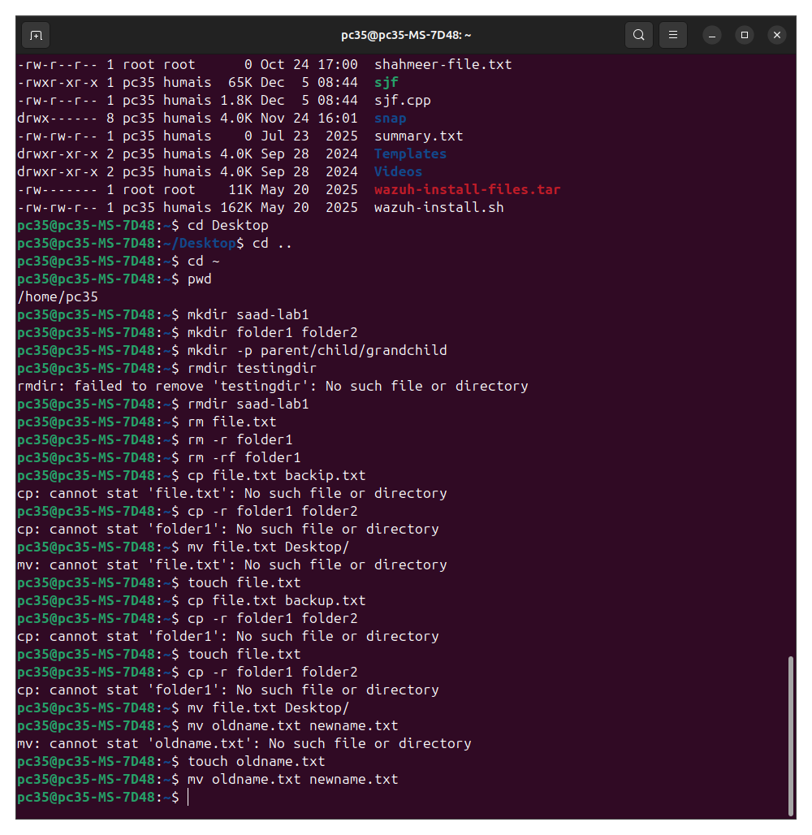

Task 2
top: shows real time real-time system performance.
ps: Shows processes running in the current terminal.
Ps aux: shows all the processes running.
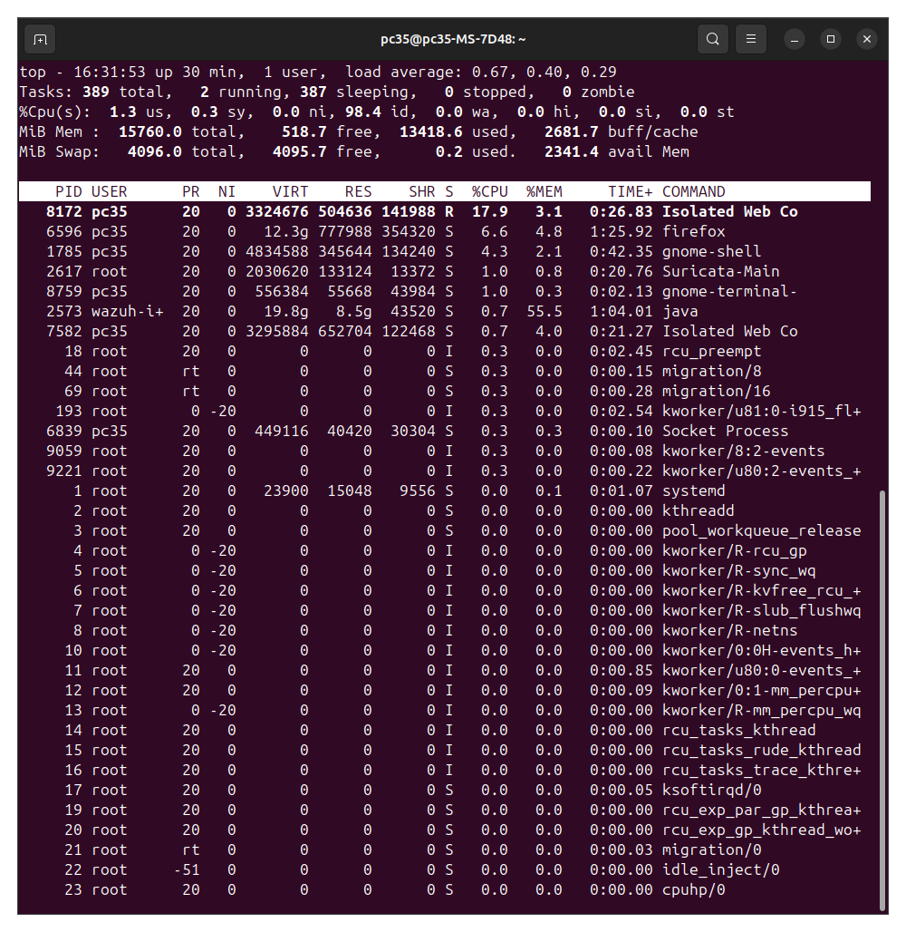
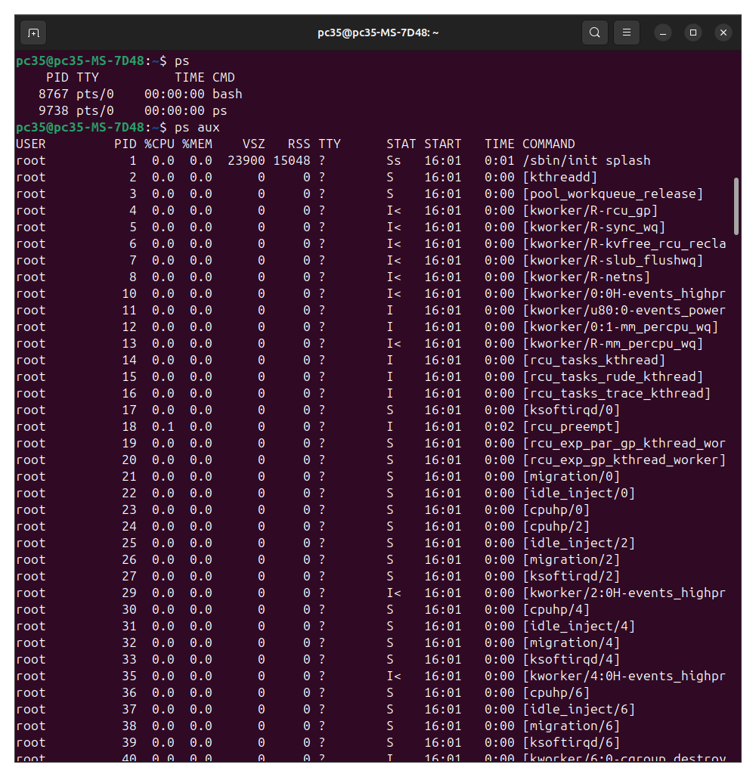
kill: this sends the signals to processes to kill them, process id is to be given.
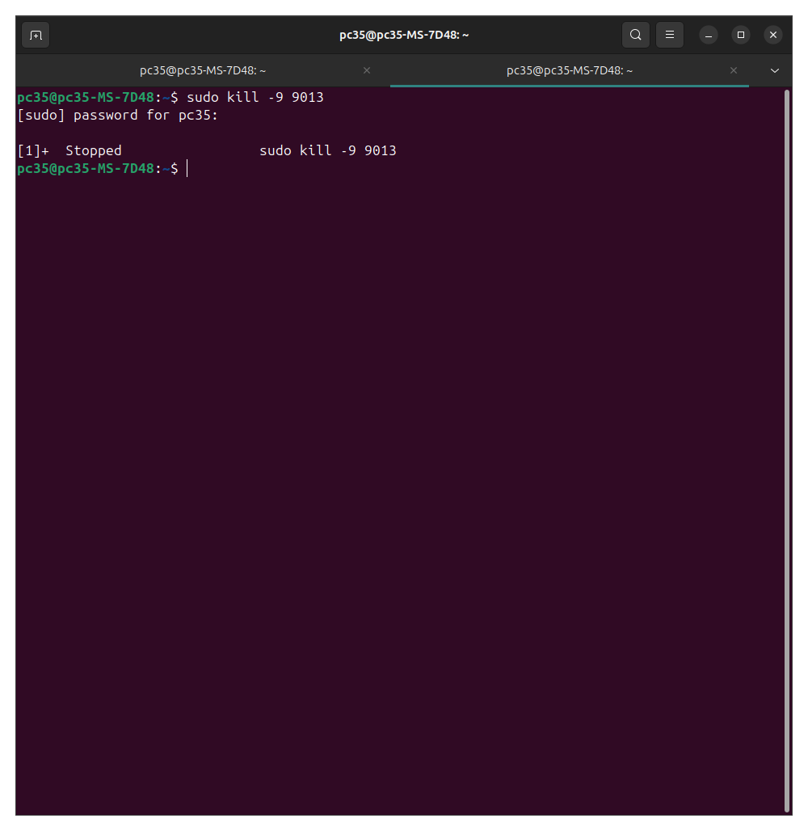
touch: creates a file
ls: used for listing
ls -l: used for checking permissions
chmod: to change permissions
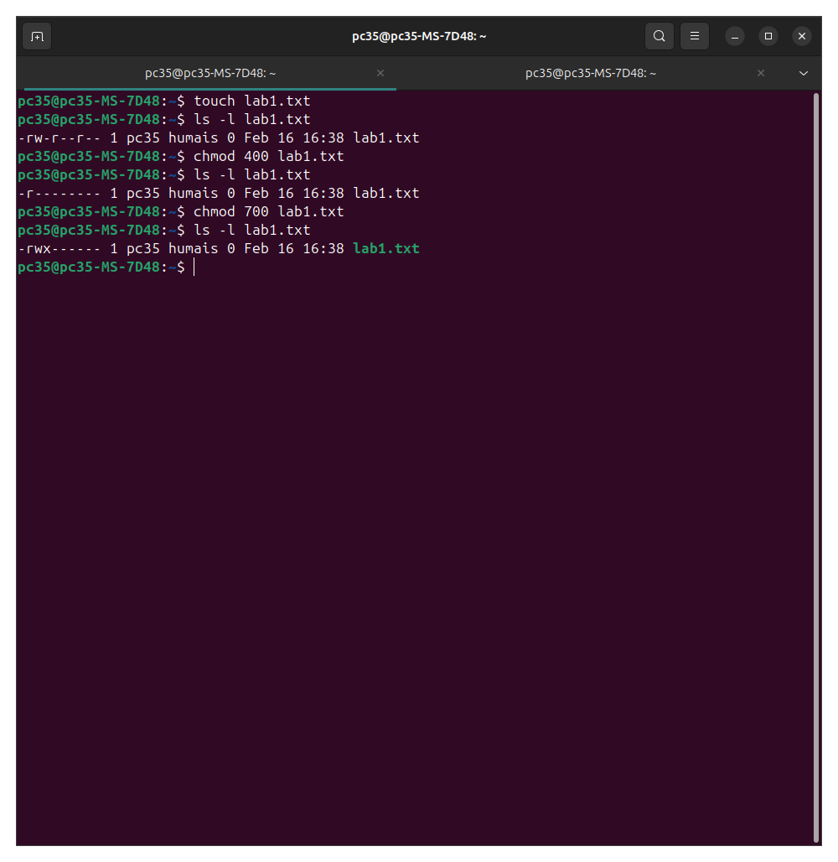
sudo apt install net-tools: to install ifconfig
Ifconfig: shows ip address, mac address etc.

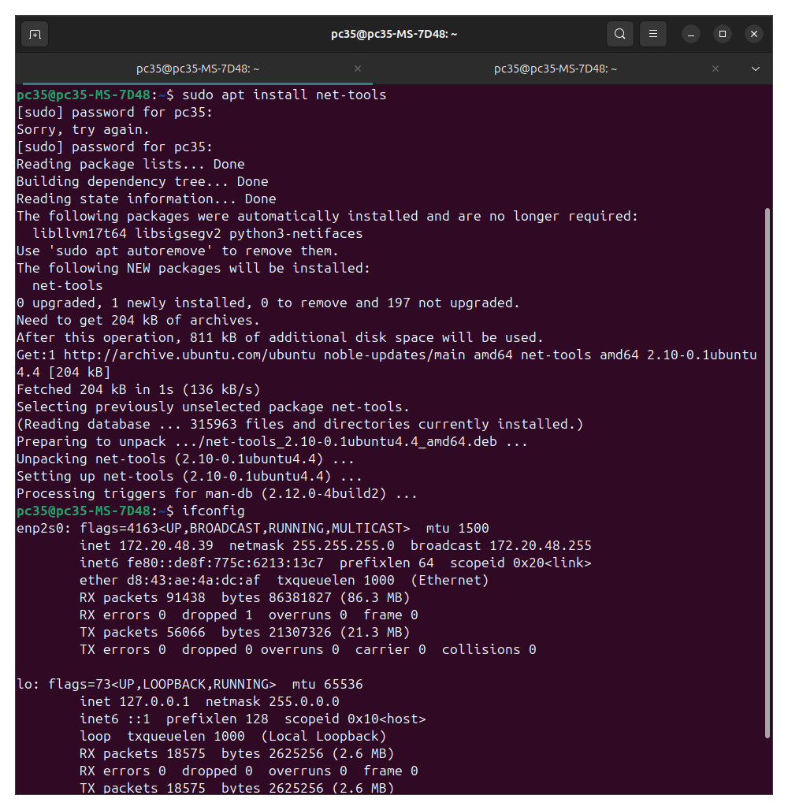
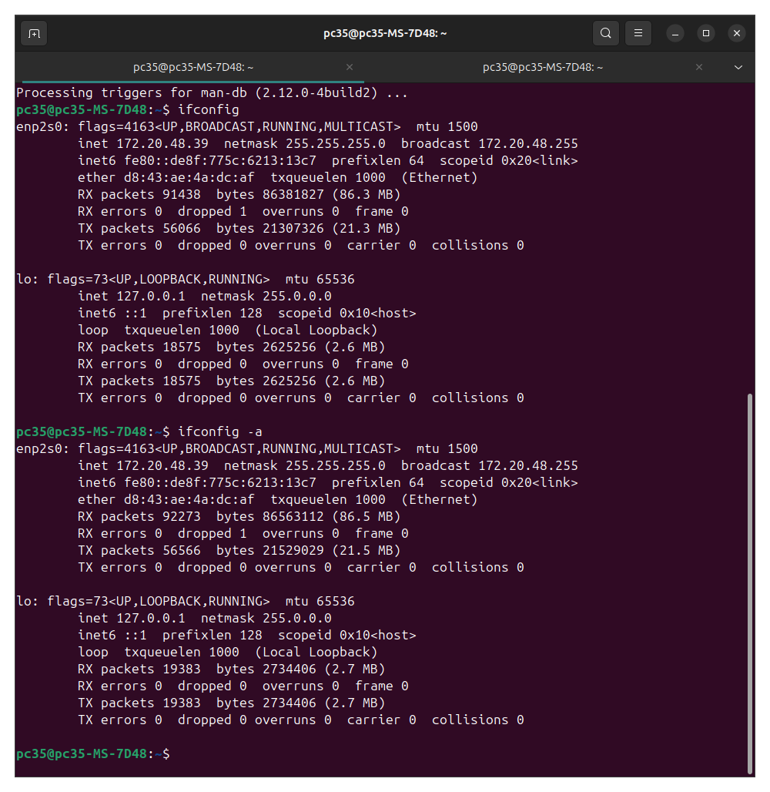
ip route: displays the system’s routing table, showing how network traffic is directed, including the default gateway and destination routes.

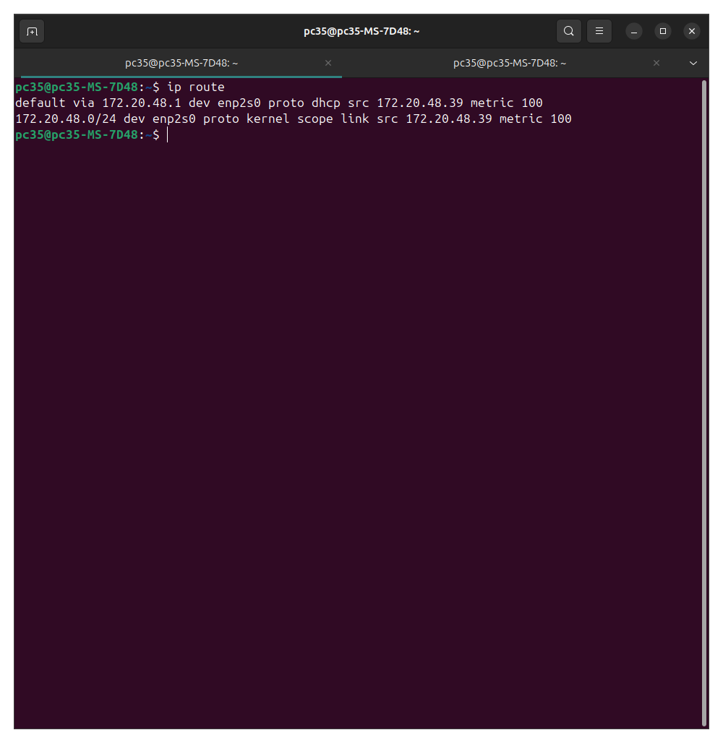
sudo apt install traceroute: to install traceroute
traceroute: lists all routers, shows path packets take to reach destination, displays latency for each hop.
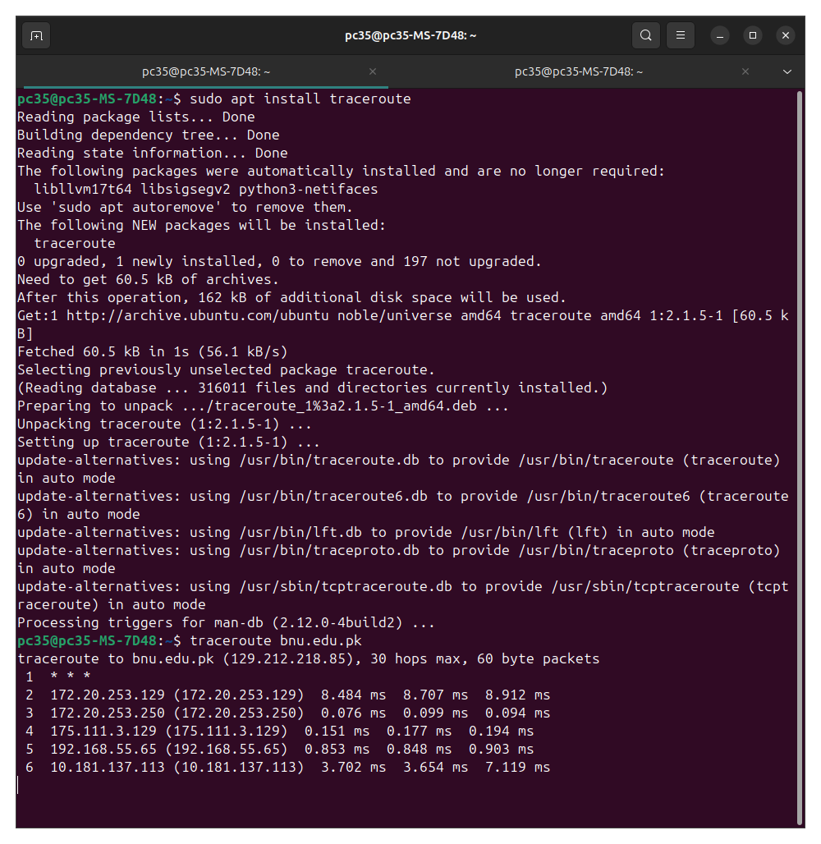
ping: checks connectivity and measures latency.
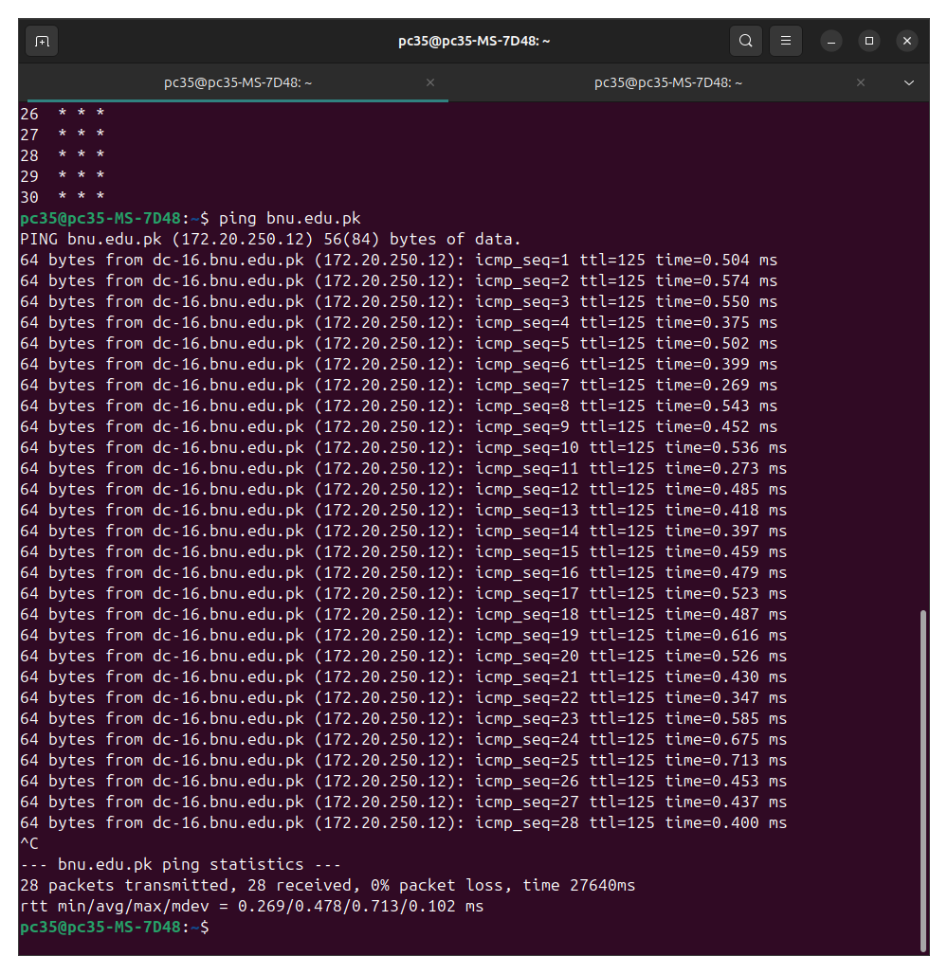

Task 3
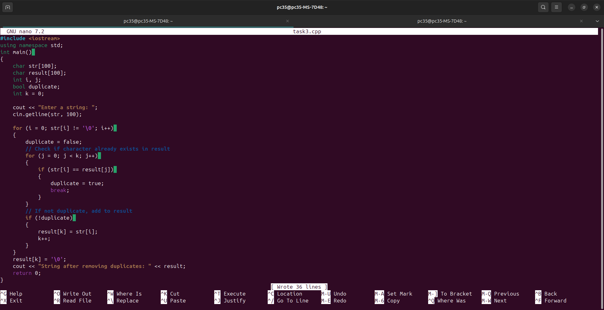
#include <iostream>
using namespace std;

int main()
{
char str[100];
char result[100];
int i, j;
bool duplicate;
int k = 0;

cout << "Enter a string: ";
cin.getline(str, 100);

for (i = 0; str[i] != '\0'; i++)
{
duplicate = false;

// Check if character already exists in result
for (j = 0; j < k; j++)
{
if (str[i] == result[j])
{
duplicate = true;
break;
}
}

// If not duplicate, add to result
if (!duplicate)
{
result[k] = str[i];
k++;
}
}

result[k] = '\0';

cout << "String after removing duplicates: " << result;

return 0;
}

